Make access key and authenticate container
This is continue task 5 from Exercises: Deployment to Cloud
Step 3
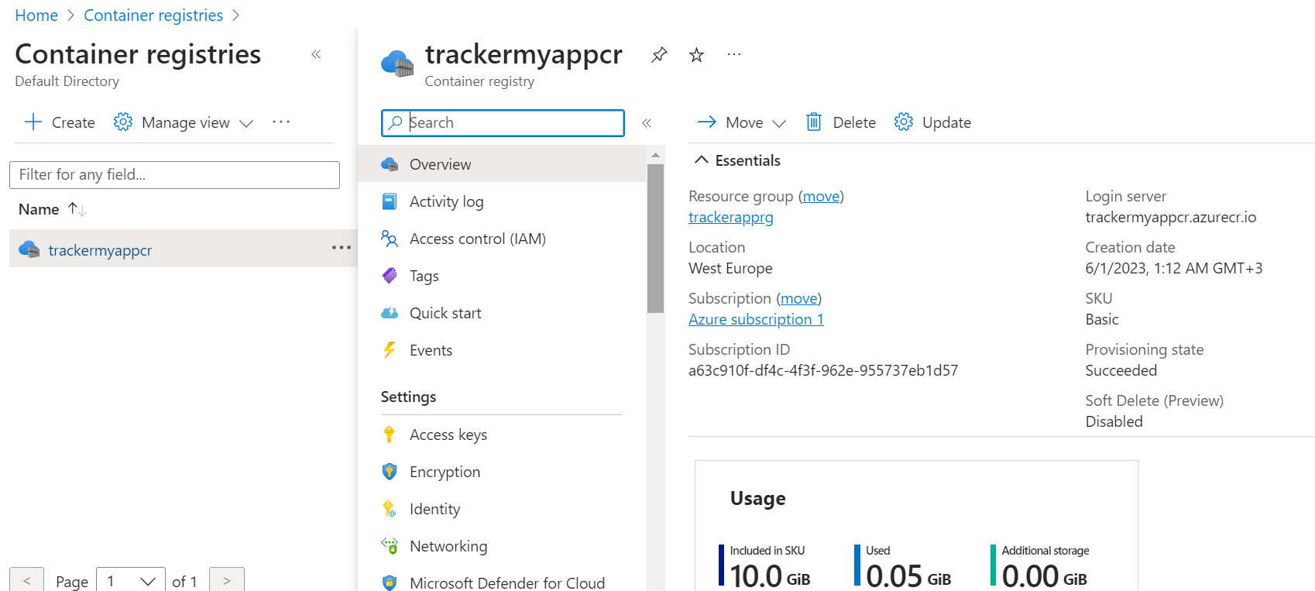

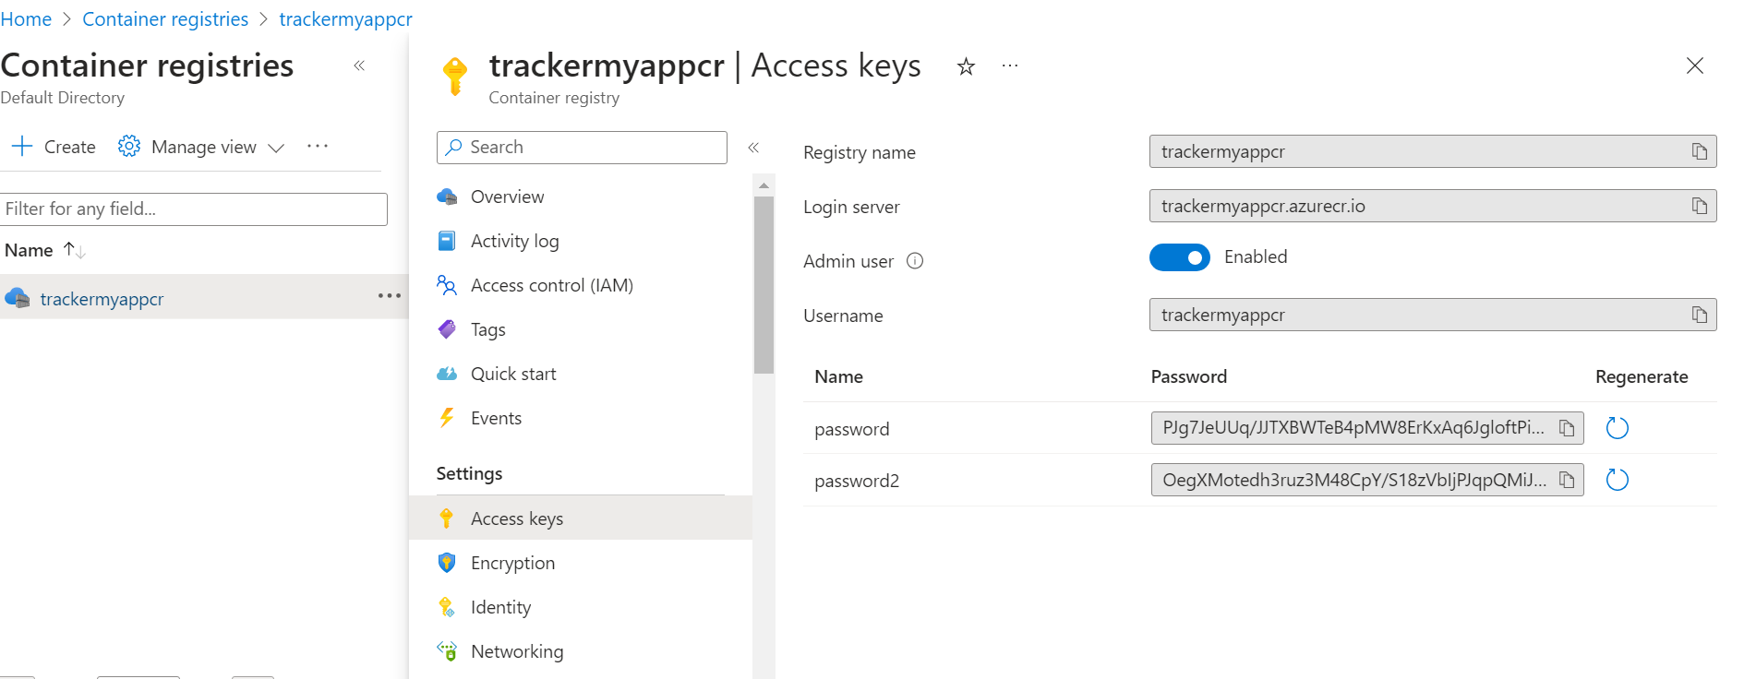

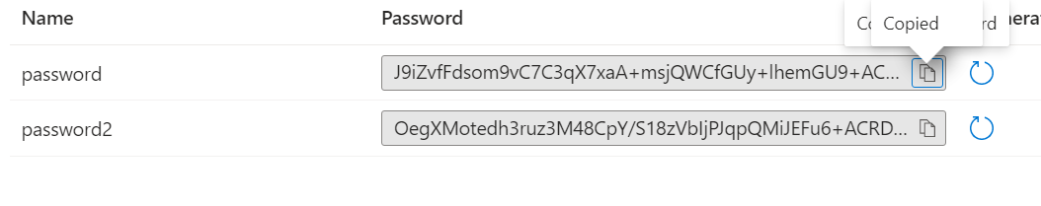
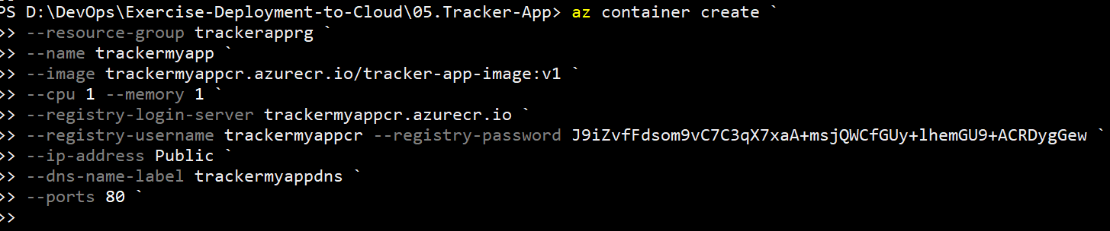
PS D:\DevOps\Exercise-Deployment-to-Cloud\05.Tracker-App> az container create `
>> --resource-group trackerapprg `
>> --name trackermyapp `
>> --image trackermyappcr.azurecr.io/tracker-app-image:v1 `
>> --cpu 1 --memory 1 `
>> --registry-login-server trackermyappcr.azurecr.io `
>> --registry-username trackermyappcr --registry-password J9iZvfFdsom9vC7C3qX7xa…`
>> --ip-address Public `
>> --dns-name-label trackermyappdns `
>> --ports 80 `

https://learn.microsoft.com/en-us/rest/api/storagerp/srp_error_codes_common

domain name in yml file
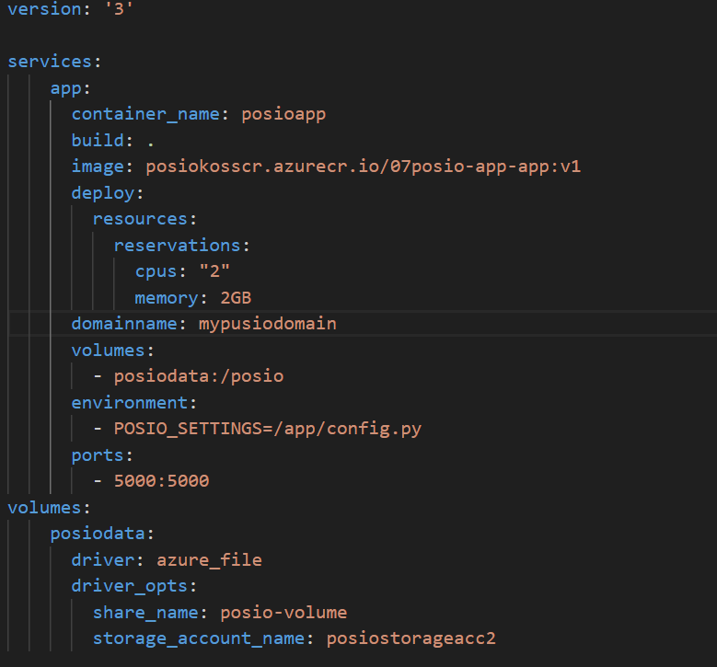

Delete image from azure container registry

az acr repository delete --name myregistry --image acr-helloworld:latest

Deploy with github repository and github action
Step 1
Create web project + database
Step 2 edit aplication
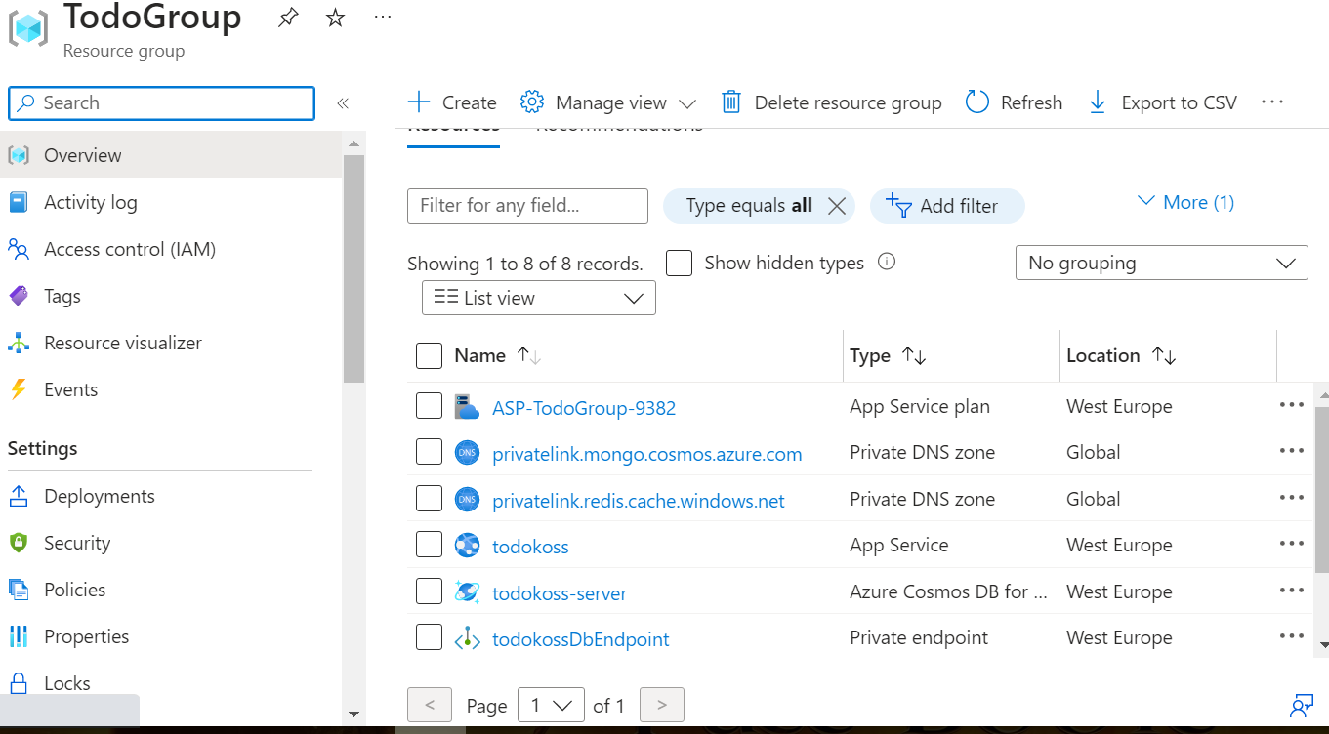
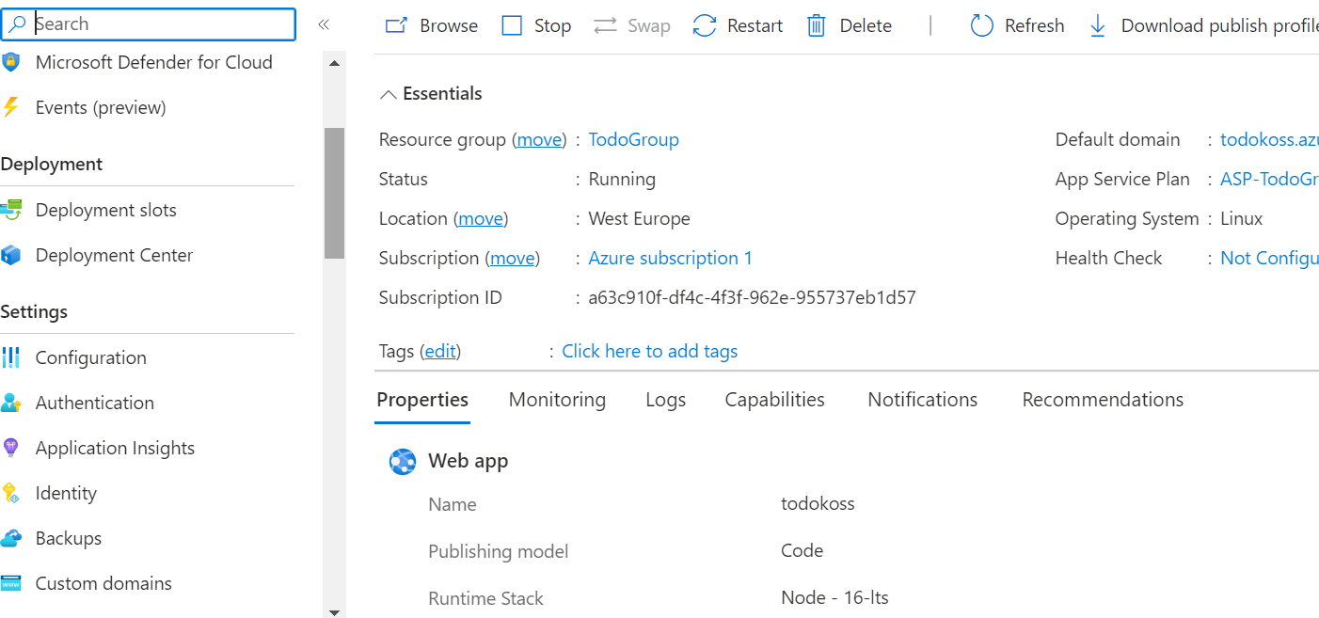

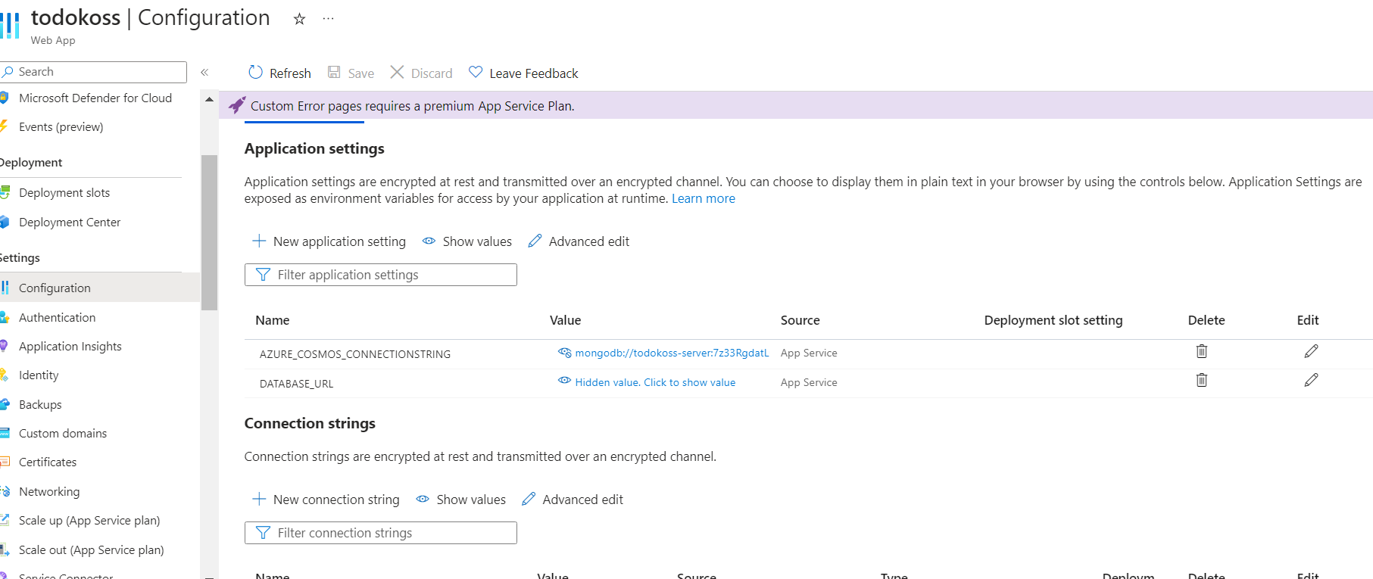

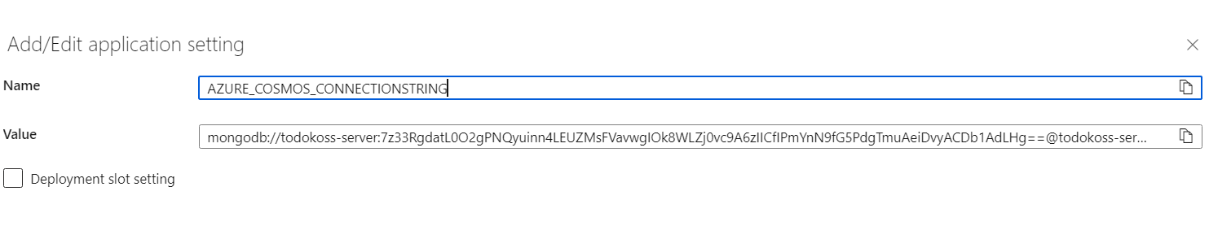
Copy value and paste in new setings


Set new name, take this from your local app ,configuration file

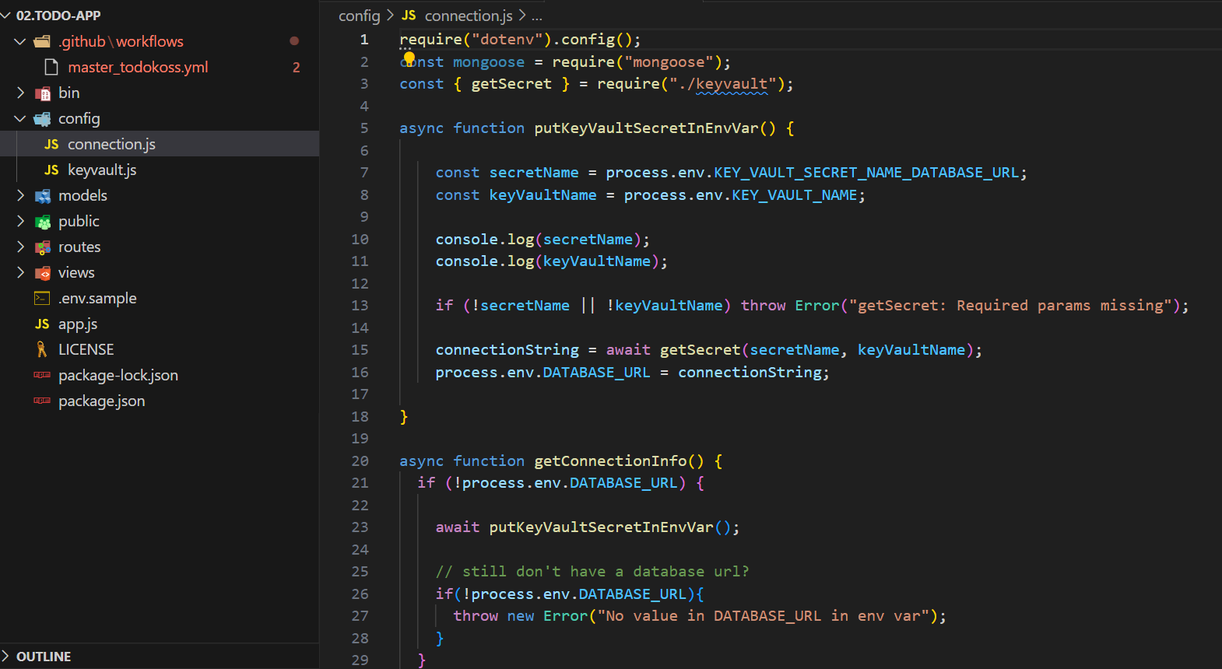
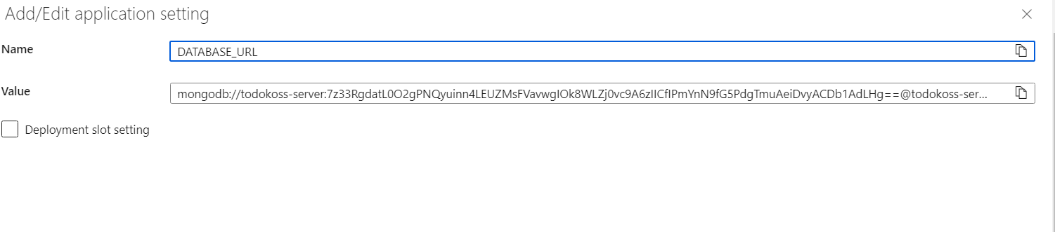
Paste value

Save setings
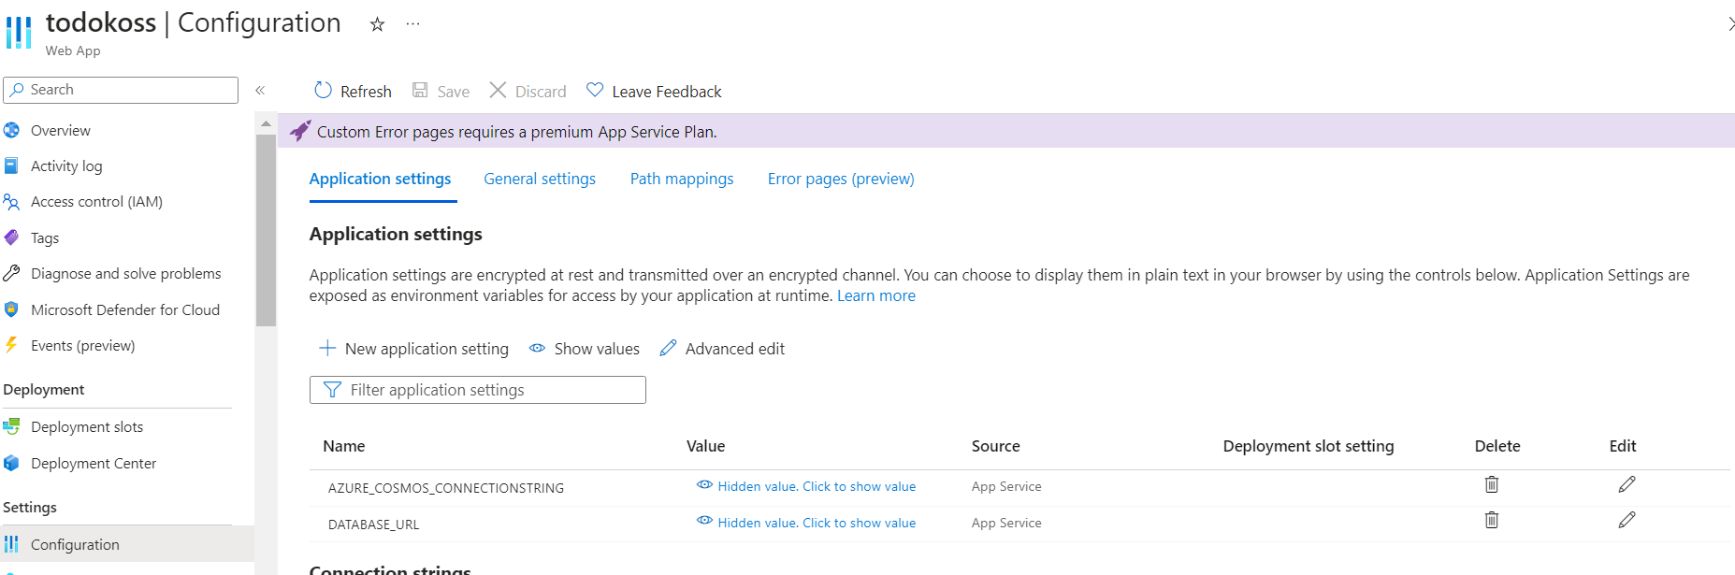

Step 3
Set git hub repo
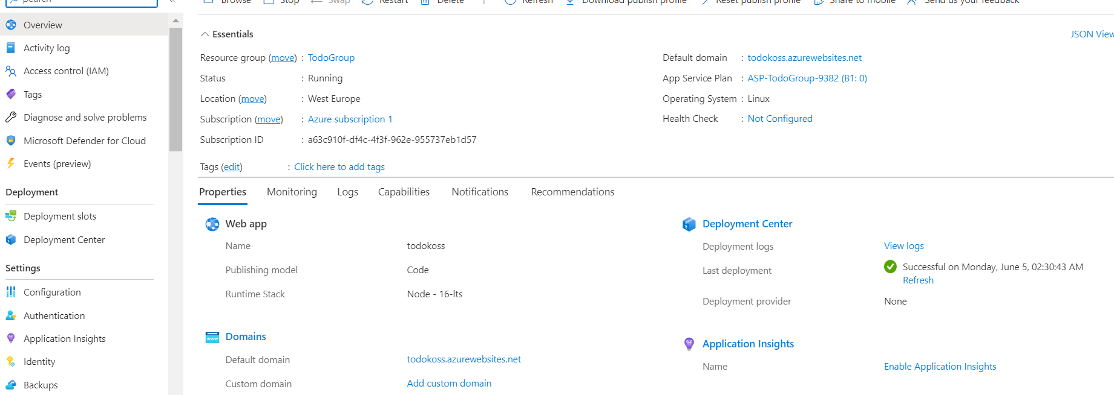

Check deployment in git hub
